August 2012
Issue 77

Welcome, to yet another offering from the stable of M0BPT.
As I prepare this for publication; the Silver Jubilee week is now a memory, logs and reports are already arriving. I look forward to reading the comments made.
<oo0oo>

On to reports and comments made during the August ladder.

From Erkki OH7QR
Hello Robert,
Please find attached my log for August Ladder. A bit better result than in July. 20M is still the best band from here, later in the autumn I can work also on 40/80 M.

Hello Erkki. Good to hear from you. The autumn is arriving, I hope your low band activity will produce good results
<oo0oo>

A warm welcome to Alex. PA1FOX, who writes;
Hello Rob
Please find enclosed my first ladder results of Sunday August 26th. I am not sure about the points, but I think it should be correct.
I was active from my holiday location near Breda on Sunday when I heard quite some fists stations around 7028 calling. After listening some time it appeared it was ladder time. It was good practice for working with the paddles. Normally I use a sideswiper. During the afternoon session I made four contacts, it was fun.
73, Alex PA1FOX #15884

Hello And welcome Alex, a perfect log.
Glad you managed to get on and say hello.
<oo0oo>

And from Phil. 2E0DPH

Hello Rob,
Hope you are well, here is my log for the August Ladder Activity.
Varying conditions but on the whole not to bad for either session this month here in Ely. Plenty of activity especially in the afternoon on the second Sunday, it was good to hear so many members on the air, a shame I didn’t have time to work all those heard in the 2 hour session.
It was also very pleasing to work Alex PA1FOX and G5VZ Chris for the first time, thanks to all.
Until next month.
73 Phil 2E0DPH Fists 14543

Hello Phil. Good to hear from you with your report, Nice that you’ve got two new members in the log. Weird and wonderful condx of late but hoping that the bands will show us good propagation.
<oo0oo>

Geoff. G0DDX Writes.
Robert.
An appalling month for me. Hopefully it will improve soon.
Regards
Geoff G0DDX Fists:15552

Hello Geoff. As long as you can find time to get on and meet the membership, all is not lost. I’m sure you’ll have a good September session.
<oo0oo>

From Peter G4LHI
Hello Robert,

I attach my claim & report for Activity Ladder August 2012.
Well Rob, it is such a pleasure to say conditions were “good” for the August Ladder. I thoroughly enjoyed the event as usual, but the good conditions made it so much more enjoyable.
The 26th session was better than the 12th as far as reports went
For August I had 19 QSO’s for 40 points, more like old times hi.
I worked one new member, welcome to the Fists Club & Ladder event Alex, PA1FOX & many thanks for the nice QSO & points.
Thank you also Graham for operating MO5IPX, nearly missed you way down there in the noise hi, but you know you can’t hide from us!

Keep bashing the brass & good hunting to you all, & most of all have fun whatever the conditions!
73 de Peter G4LHI # 2219

Hello Peter. As ever a concise and welcome report from yourself. As said earlier, condx do seem to be variable, with almost dead bands, then a complete turnaround to a more bouyant set of circumstances.
I did read a post on the FISTS News group asking “Who’d turned 40M off?” Hi Hi.
<oo0oo>

From Derek. M0DRK
Hi Robert, Here attached is my Fists Ladder Log for August.Many thanks to all stations that gave me points. Very pleased to meet Bern, GM4WZG for the first time. David, G3SCD was another call that was a nice surprise, hope that I can work you again David when you return to VK. Rob, M0TIX was an unexpected call. Don't hear you often enough even though our home qths are almost within spitting distance of each other, hi. MO5IPX was my final Ladder call for the month and thanks to Gra, a nice 5 pointer to finish on.
Hope all is well with you and your family Robert, both of us still ticking over nicely here. See you next month, take care, Derek, M0DRK, 8344.

Hi Derek. Good to hear from you. It’s always nice to hear that members meet for the first time and aquaintances renewed during the ladder activity.
Regards to yourself and Mollie. Good to hear you’re both doing ok.
<oo0oo>

And from Peter. G0TLU
Hi Rob,
I missed the first Sunday session in August as I attended the Flight Refuelling Rally at Wimborne. This has always been one of my favourite rallies, even better this time as I managed to obtain a NATO key. I've been after one of these since seeing it featured in one of Sandy G0VQW's YouTube videos. The seller was sorry to see it go, but cheered up a bit when I assured him it was going to a good home and would be used on the air. Looking forward to Straight Key Week now when I'll be using that along with my Czech Army Key.
73, Pete G0TLU.

Hi Pete. Never had the pleasure of visiting the rally you mention; I must make a metal note and put it on my “Things to do” list.
I’ve noticed that the NATO keys are commanding good prices of late, you don’t see them come up for sale all that often these days. Of course, they are made to be used and I’m glad that your new addition will be.
As many are we aware, the society attended the Telford Hamfest with the stall where Mike was also in attendance. Needless to say, a Czech army key is now in my possession. I haven’t had the time to remove it from the wrapping yet!
SKW will be its baptism no doubt.
<oo0oo>

And from Gra. G3ZOD
Hi Rob.
A very good month for me on the Ladder. I had forgotten that previously when I had electrical noise problems on 40m, I had used a short 5' whip on my desk as a receive-only aerial, giving somewhere around 9dB improvement in signal to noise. Now I've resumed using it, the balance between transmit inefficiency on my main aerial and the insensitivity due to electrical noise is more or less even again.
73 de Graham G3ZOD

Hello Gra. I must look into your idea of using a separate receiving aerial to counteract the high electrical noise here at M0BPT. Pleased that you had a good month on the ladder
<oo0oo>

Some awards news from Dennis. K6DF
August 2012 FISTS Awards

Congratulations to the following members:
Raymond WB0PYF #7986
Prefix Version 1 and Prefix Version 2

Gary AB0BM #13663
Millionaire 3 Million Sticker
<oo0oo>

Some news from Bevan, VK4BCM
Hi Friends,
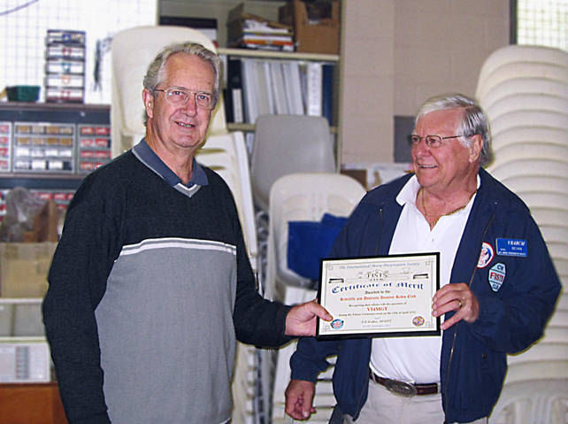
Yesterday, the 23rd of August; I presented a Certificate of Merit on behalf if FISTS International to Roger Dunn VK4ZLQ Secretary of the Redcliffe & District Amateur Radio Club during a club meeting.
The Redcliffe amateurs were 100% supportive of the Titanic event to the point that it would not have been possible without their enthusiastic participation. Some members who were not CW operators also supported us with logistics, setting up & dismantling, transport and general public relations during the event. This acknowledgement from FISTS was appropriate and will be proudly displayed in the main room of the Club rooms.
Bevan McAleer FISTS 9053 VK4BCM

As many of you are aware, Bevan
And the Redcliffe amateurs (and XYL’s) did a great job promoting amateur radio, making people aware of the hobby, the fact that Morse is still used, and the importance of the mode during the tragedy.
A sterling effort by them all!
<oo0oo>

Some news from Stathis Maliakis, SV5DKL,

PLEASE FORWARD THE FOLLOWING MESSAGE TO YOUR MEMBERS.
Good morning to all of you.
GTC CW Cup committee would like to remind you that the 2nd GTC CW Cup will be held
on 6th October 2012 – 1200UTC until 7th October 2012 – 1200UTC. We are all going to be there and
It will give us great pleasure to work you.
It was really great to see many new members joining GTC after the 1st GTC CW Cup, resulting to our current members totaling 282 (up to 19th September 2012)!!
For this year`s GTC CW Cup, renewed rules are applied and attached for your reference, and also
special contest software written by Kresimir, 9A5K, is freely available from the official site of GTC.
You may download the software by visiting the following link:

http://www.raag.org/displayITM1.asp?ITMID=516&LANG=EN
Top scorers of categories A and B will receive, again this year, beautiful trophies
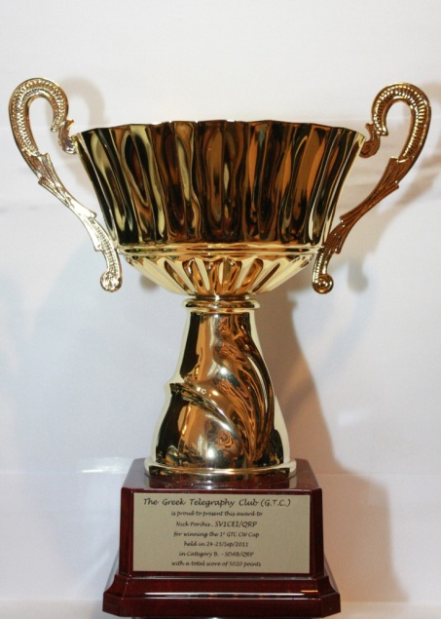
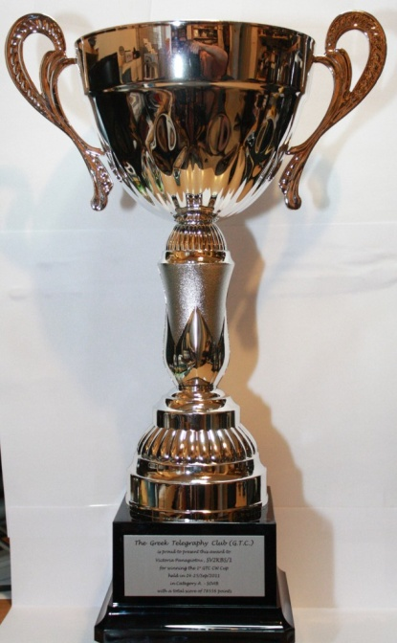
!! Please take the time to read the new rules carefully and comply with them !!
We hope to hear you on air!
Vy 73 & 55
Stathis Maliakis, SV5DKL,
E.C.M. of Greek Telegraphy Club
G.T.C. #028
GTC CW Cup Contest Manager
<oo0oo>

On to the ladder results for August

CALL | JAN | FEB | MAR | APR | MAY | JUNE | JULY | AUG | SEPT | OCT | NOV | DEC | TOTALS
G4LHI | 36 | 36 | 44 | 46 | 40 | 33 | 25 | 40 |  |  |  |  | 300
2E0DPH | 29 | 30 | 44 | 27 | 32 | 31 | 29 | 32 |  |  |  |  | 254
G0OTT | 24 | 31 | 32 | 37 | 27 | 31 | 30 | 0 |  |  |  |  | 212
OH7QR/OG9R | 31 | 25 | 30 | 23 | 6 | 27 | 24 | 30 |  |  |  |  | 196
M0DRK | 23 | 20 | 29 | 26 | 15 | 16 | 17 | 23 |  |  |  |  | 169
G0DDX | 20 | 25 | 29 | 0 | 7 | 16 | 10 | 4 |  |  |  |  | 111
G3ZOD | 8 | 19 | 10 | 18 | 6 | 16 | 6 | 17 |  |  |  |  | 100
M5ABN | 27 | 31 | 11 | 0 | 0 | 0 | 0 | 0 |  |  |  |  | 69
G0TLU | 0 | 0 | 15 | 10 | 9 | 14 | 7 | 6 |  |  |  |  | 61
2E0JCY | 0 | 0 | 18 | 14 | 0 | 0 | 0 | 0 |  |  |  |  | 32
G0DUB | 12 | 6 | 11 | 0 | 0 | 0 | 0 | 0 |  |  |  |  | 29
G0ANV | 8 | 0 | 0 | 20 | 0 | 0 | 0 | 0 |  |  |  |  | 28
DL4FDM | 0 | 17 | 8 | 0 | 0 | 0 | 0 | 0 |  |  |  |  | 25
CN2JV | 4 | 0 | 6 | 0 | 0 | 0 | 0 | 0 |  |  |  |  | 10
PA1FOX | 0 | 0 | 0 | 0 | 0 | 0 | 0 | 8 |  |  |  |  | 8
SQ5RIX | 0 | 7 | 0 | 0 | 0 | 0 | 0 | 0 |  |  |  |  | 7
SA0AAZ | 0 | 0 | 0 | 6 | 0 | 0 | 0 | 0 |  |  |  |  | 6
MM6SRL | 0 | 0 | 0 | 0 | 0 | 0 | 6 | 0 |  |  |  |  | 6
SM6DER | 0 | 0 | 0 | 0 | 0 | 0 | 2 | 0 |  |  |  |  | 2
MX5IPX © | 3 | 11 | 3 | 12 | 13 | 14 | 10 | 16 |  |  |  |  | 82
GX3ZQS © | 0 | 12 | 0 | 10 | 0 | 0 | 0 | 0 |  |  |  |  | 22
GX0IPX © | 0 | 0 | 19 | 0 | 0 | 0 | 0 | 0 |  |  |  |  | 19

Things progressing along nicely.
That’s all from M0BPT for another month, thanks to all concerned for their input, without you all, there wouldn’t be a BP.

Finally, I’ve rigged up a “Heath-Robinson” indoor doublet to get me back on the air temporarily, still going through the evaluation stage at the moment so don’t be surprised if you hear me call in with a poor signal! Hi Hi..

Until next time.
Keep well
Keep pounding brass!
73
M0BPT

